

What is a Biosketch?
A biographical sketch (also referred to as biosketch) documents an individual's qualifications and experience for a specific role in a project. (Source: https://grants.nih.gov/grants/forms/biosketch.htm)
Welcome to PHENOM! The online mentoring program is provided with the use of an online directory that is accessible to anyone who has access to the Internet.
The purpose of populating the directory with brief biosketches is to allow potential mentees a chance to see what expertise each mentor possesses. This makes it easier for the mentee to determine which mentor they may wish to contact via either by E-mail or phone. Currently, most mentors provide an E-mail than a phone number.
Here is a sample:
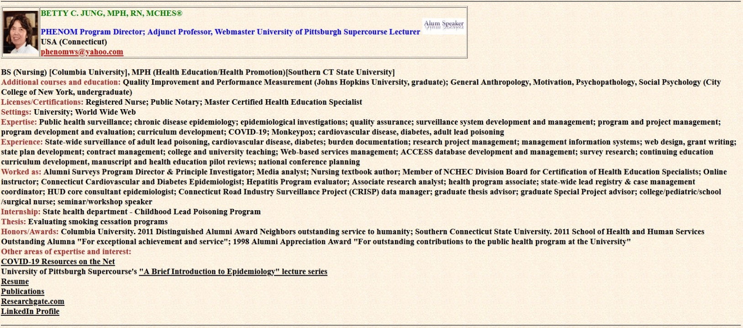
The following is a template you can use to organize your personal and professional information for the directory. You can choose which type of expertise to highlight.
Once you have completed the template, just E-mail it to me and I will convert it into HTML format so it can be posted online.
Complete the following template with your own information and then E-mail this document to me as your biosketch to the email below.
Keep all red headings. You can delete the guidance in blue as you enter you own information in black.
E-mail if you have questions at: phenomws@yahoo.com
Photo goes here, if you have E-mailed your headshot, you are all set, if not, attach it to the E-mail you are sending with your biosketch. | Your name, degree(s), license(s), certification(s)  Current job titles  Geographic location (Country, City)  E-mail &/or phone where you can be reached.

Academic degrees, starting with your earliest (Major in parentheses) [Name of institution in brackets]
Additional courses and education: These would be additional college courses you have taken pertinent to your current expertise, and non-academic credit type certificates related to your current career path.
Licenses/Certifications: Include titles you are licensed in, then titles you are certified in.
Settings: Where you work. Do not include the name only the type of setting. For example, university, Internet, hospital, health department (you can include local/county, state, federal), non-profit, for profit, etc. The reason for not including the name of your work setting is to reduce contacts from people looking for jobs at a specific institutions. As PHENOM mentors you only need to provide general guidance regarding potential career paths and not serve as connections for getting a job. For example, you can share what it’s like to work as an epidemiologist at a local, state or federal agency. If you have worked at more than one public health level, you can offer insight into the differences between working for, say, a local or state health department. If they are interested in working for a health department, you can refer them to the local or state government Web sites where they can apply.
Expertise: This is where you can provide a list of your special skills that set you apart from others. If you have computer skills, what specific computer skills do you have? Are an expert in data management, statistical analysis, developing infographics? If you have program management skills, do those skills include grant writing, budgeting, fiscal oversight, program evaluation?
Experience: What have you actually done that you can show you have done? Have you managed a database, conducted pilot testing, conducted a program evaluation, written up a planning document, conducted a training session, and taught classes?
Worked as: In this section you list all your previous job titles, starting with the most recently held, and then work backwards in time. For example, if you are now a project supervisor, your previous jobs could haven been research analyst, research assistant, data entry operator, etc.
Internship: Did you complete an internship while you were in college? That’s work experience. For example, local health department – develop a health education pamphlet about COVID-19 vaccines.
Thesis: Or, theses. Start with your most recent, and then work backwards in time, if you have more than one.
Honors/Awards: Brag. You earned the right to. Start with the most recent and work backwards. For example, Spring County Association (2015) Community Champion for Physical Activity; ABC University (2010) Outstanding alum of the year; XYZ College – Department of Biology (2002) Outstanding Advanced Biology student.
Other areas of expertise and interest: In this section you can include things you are involved with and passionate about. Is there something you did for a community that was written up online? Include the link here. Want to share all that research you have been involved in? Include a link to Academic.edu or Researchgate.com In the past people have contacted me where they can collaborate with others on research projects, etc. If you have a LinkedIn Profile, I will usually include that at the end in the event people may want to learn more about you. I try my best to make sure your social media profiles are consistent in case you may be job-hunting. I know some people in HR and they tell me they do search social media on potential hires and red flags for them are no social media references and inconsistent social media references.
Ok, so I help this will be helpful for you in developing your own biosketch for the PHENOM Directory. Once you are done, just E-mail it to me and I can work on formatting it for the directory. If you haven’t submitted a headshot, make sure include that!
This is also good practice run to developing a biosketch. You may be asked to develop one. Doing this, you will already have one ready to go, with possibly a few minor edits.
Thank you again for your willingness to mentor!
Betty
PHENOM Director

